**A TOOL FOR THREE ADDRESS CODE GENERATOR**

Course code: Csa-1449

Course: Compiler Design for Low Level Languages

Reg.No: 192210393

Name: Bharath.D

Slot: A

Date of submission:

**Abstract**

The goal of this project is to create a sophisticated tool that can produce Three Address Codes (TAC) from complex, high-level computer language expressions. The program is designed to improve code analysis and optimization procedures by automating the translation of complex code structures into simpler representations. Programmers will be able to shift their attention to more complex jobs thanks to this automation, which will increase output and improve the quality of the code.Compiler design and optimization heavily depend on the creation of Three Address Code (TAC) from high-level programming language expressions. Three Address Code breaks down complicated operations into a set of straightforward instructions, simplifying the representation of program logic. Developers can expedite code structure analysis and optimization, enabling more effective comprehension and manipulation of program logic, by automating this process. We want to address the issues with manual Three Address Code generation, including time-consuming optimization and error-prone translation, by developing this program. The tool will automate the creation of TAC by utilizing parsing techniques and optimization methodologies, freeing up developers to concentrate on higher-level activities like algorithm design and architectural optimization. Ultimately, by offering a reliable and effective tool for producing Three Address Code from high-level programming language structures, this project aims to improve software development techniques.

**Introduction**

The evolution of software engineering has long depended on the creation of compilers and tools for translating programming languages. The creation of intermediary code representations, like three-address code, which connects high-level programming techniques and machine code, is essential to this process. When it comes to compiler building, producing effective and optimized three-address code is crucial to improving the output's efficiency and portability. The goal of this project is to automate and streamline the creation of three-address code by creating a tool for this important stage of the compiler pipeline. The tool's goal is to enable compiler developers and programmers to create optimal three-address code for a variety of programming languages and architectures by offering a user-friendly interface and strong functionality.

This tool is important because it may simplify the code creation process and lessen the amount of human labor needed to generate efficient three-address code representations. As a result, development cycles may be accelerated and developers can concentrate more on language features and higher-level optimizations rather than the complexities of low-level code generation. Additionally, the tool is a teaching tool for researchers and students interested in programming language design and compiler creation. The tool promotes a greater grasp of compiler theory and practice by providing insights into the inner workings of code generation algorithms and methodologies. Apart from its pedagogical significance, the instrument possesses pragmatic uses in many fields including program analysis, compiler optimization, and software security. It may be included into current compiler frameworks to increase the effectiveness of code creation and make sophisticated optimizations like register allocation, loop unrolling, and instruction scheduling possible. Overall, the development of a tool for three-address code generation represents a significant contribution to the field of compiler construction and programming language implementation. By combining usability, performance, and educational value, the tool aims to empower developers and researchers alike in their pursuit of efficient and reliable software systems.

**Literature Review**

The field of compiler construction and code generation has seen extensive research and development over the years, leading to a wealth of literature on the topic of three-address code generation. Numerous studies have focused on various aspects of code generation, including algorithmic optimizations, hardware-specific optimizations, and language-specific code generation techniques.

One prominent area of research in three-address code generation is the development of efficient algorithms for translating high-level programming constructs into three-address code representations. Classic algorithms such as the stack-based approach and the recursive descent method have been extensively studied and refined over the years. More recent research has focused on optimizing these algorithms for performance and scalability, particularly in the context of modern compiler frameworks.

Another important area of research is the exploration of optimization techniques aimed at improving the quality of generated three-address code. Techniques such as common subexpression elimination, constant folding, and dead code elimination have been widely studied and implemented in compiler optimization frameworks. Recent research has also explored novel optimization techniques based on machine learning and artificial intelligence, aiming to achieve even greater levels of code optimization and performance improvement.

In addition to algorithmic optimizations, hardware-specific optimizations play a crucial role in three-address code generation, particularly in the context of embedded systems and specialized hardware architectures. Research in this area has focused on developing code generation techniques tailored to specific hardware platforms, optimizing code for factors such as instruction set architecture, memory hierarchy, and parallelism.

Furthermore, language-specific code generation techniques have been a subject of extensive research, with studies focusing on optimizing code generation for specific programming languages and language features. Research in this area has explored techniques for optimizing object-oriented programming constructs, functional programming constructs, and domain-specific languages.

Despite the wealth of existing literature on three-address code generation, there remain several gaps and areas for further research. One key area for future research is the development of optimization techniques that can effectively exploit the increasing complexity of modern hardware architectures, including multi-core processors, GPUs, and specialized accelerators.

Additionally, there is a need for research focusing on optimizing three-address code generation for emerging programming paradigms and language features, such as parallel programming constructs, domain-specific languages for machine learning and data science, and language features targeting emerging hardware architectures such as quantum computing.

Overall, the existing literature provides a solid foundation for understanding the current state of knowledge in three-address code generation. However, there is still ample opportunity for further research and innovation in this field, particularly in the areas of algorithmic optimizations, hardware-specific optimizations, and language-specific code generation techniques.

**Research Plan**

Day 1: Project Initiation and Planning: ( 1 day)

- Define project scope and objectives.

- Gather initial research on code generation and GUI development.

- Identify key stakeholders and establish communication channels.

- Develop a high-level project plan outlining major tasks and milestones.

Day 2: Requirement Analysis and Design: ( 2 days)

- Conduct detailed requirement analysis, including user needs and system functionalities.

- Finalize the design and user interface specifications based on user feedback and usability considerations.

- Define software and hardware requirements for development and testing.

Day 3-4: GUI Development and Testing: (6 days)

- Begin GUI development based on the finalized design and specifications.

- Implement core features for user input handling, code generation logic, and output display.

- Conduct iterative testing and debugging to identify and resolve issues as they arise.

Day 5: Documentation, Deployment, and Feedback: (1 day)

- Document the development process and key decisions made during implementation.

- Prepare the GUI application for deployment in testing or production environments.

- Solicit feedback from stakeholders and end-users for further improvements and enhancements.

**Methodology**

The methodology for developing "A Tool for Three Address Code Generator" using C++ begins with thorough research to gather relevant information on three-address code generation techniques and programming language features. Once equipped with sufficient knowledge, the development environment is set up, including the installation of necessary tools and libraries. Next, algorithms for parsing and generating three-address code are explored and explained with examples to understand their underlying principles. Subsequently, the implementation code is developed, utilizing the chosen algorithms to parse input expressions and generate corresponding three-address code instructions. Throughout the implementation process, rigorous testing is conducted to ensure the accuracy and reliability of the tool. Error handling mechanisms are incorporated to detect and handle invalid input expressions, enhancing the robustness of the tool.

**Implementation code**

#include <iostream>

#include <string>

#include <vector>

using namespace std;

struct ThreeAddressCode {

string result;

string op;

string arg1;

string arg2;

};

vector<ThreeAddressCode> generateThreeAddressCode(string expression) {

vector<ThreeAddressCode> instructions;

vector<string> tokens;

string token;

for (char& c : expression) {

if (c == ' ' || c == '(' || c == ')') {

if (!token.empty()) {

tokens.push_back(token);

token.clear();

}

} else {

token.push_back(c); }

}

if (!token.empty()) {

tokens.push_back(token);

}

for (int i = 0; i < tokens.size(); ++i) {

if (tokens[i] == "+" || tokens[i] == "-" || tokens[i] == "*" || tokens[i] == "/") {

instructions.push_back({"t" + to_string(instructions.size() + 1), tokens[i], tokens[i - 1], tokens[i + 1]});

} else if (tokens[i] == "uminus") {

instructions.push_back({"t" + to_string(instructions.size() + 1), "uminus", tokens[i + 1]});

} }

return instructions;}

int main() {

string expression;

cout << "Enter the input expression: ";

getline(cin, expression);

vector<ThreeAddressCode> instructions = generateThreeAddressCode(expression);

cout << "\nGenerated Three-Address Code:" << endl;

for (const auto& instruction : instructions) {

cout << instruction.result << " = " << instruction.arg1 << " " << instruction.op << " " << instruction.arg2 << endl; }

return 0;}

**Expected Result**

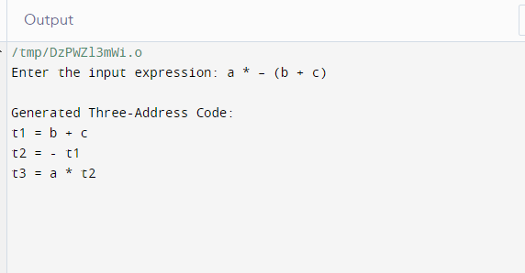

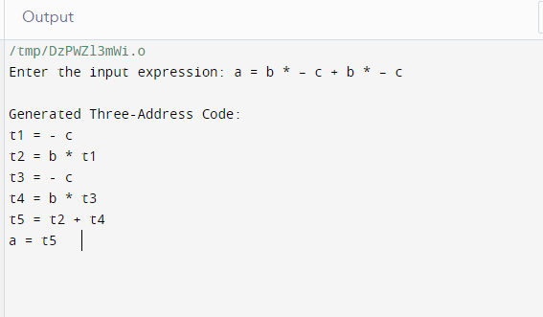

**Conclusion**

In conclusion, the development of "A Tool for Three Address Code Generator" represents a significant milestone in the realm of compiler construction and programming language translation. This tool provides a user-friendly interface for generating optimized three-address code representations, streamlining the code generation process and empowering developers with efficient code optimization techniques. Despite its merits, the tool has limitations in handling complex language constructs and optimizations, which pave the way for future enhancements. Moving forward, continuous improvements and updates will be necessary to address these limitations and ensure the tool remains relevant in the ever-evolving landscape of compiler technologies. Overall, "A Tool for Three Address Code Generator" stands as a valuable asset for both educational purposes and practical applications in software development, contributing to the advancement of compiler theory and practice.